Synthesis, Spectral and Biological Studies of Co(II), Fe(II), Ni(II), Cu(II), Pd(II), Mn(II), Hg(II), Cd(II) and Zn(II) Complexes Derived From Benzohydrazide Schiff Base

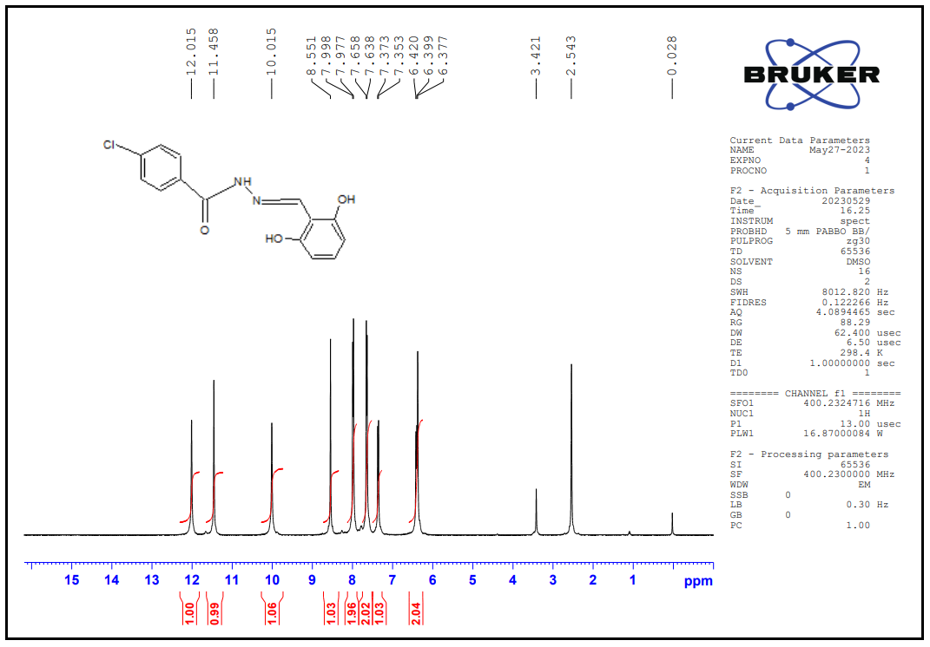
Figure 1: NMR spectrum of HBHDH ligand
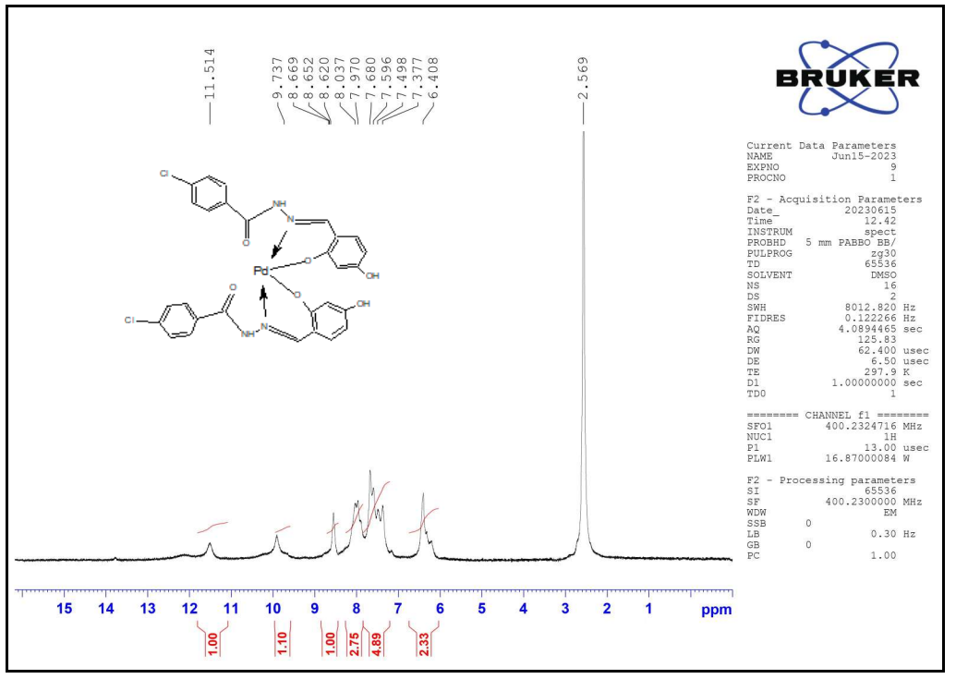
Figure 2: 1HNMR spectrum of [Pd(BHDH)₂]complex
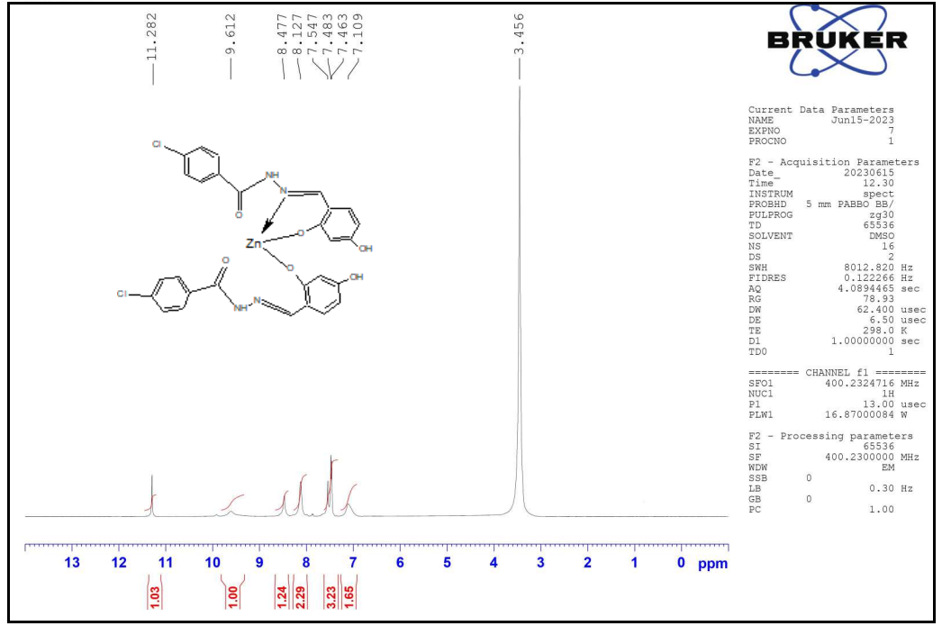
Figure 3:NMR spectrum of [Zn(BHDH)₂] complex
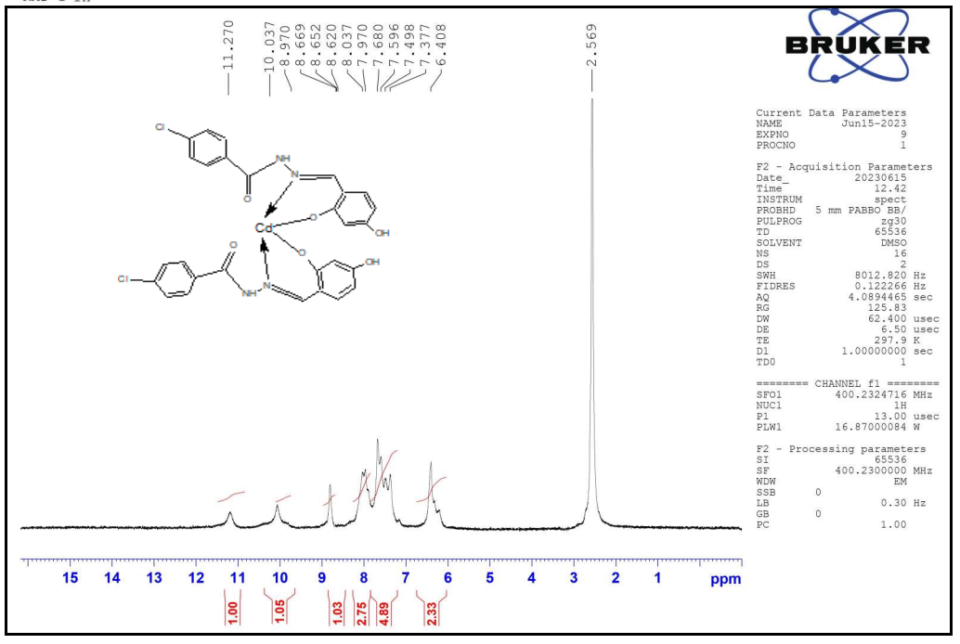
Figure 4:NMR spectrum of [Cd(BHDH)₂] complex
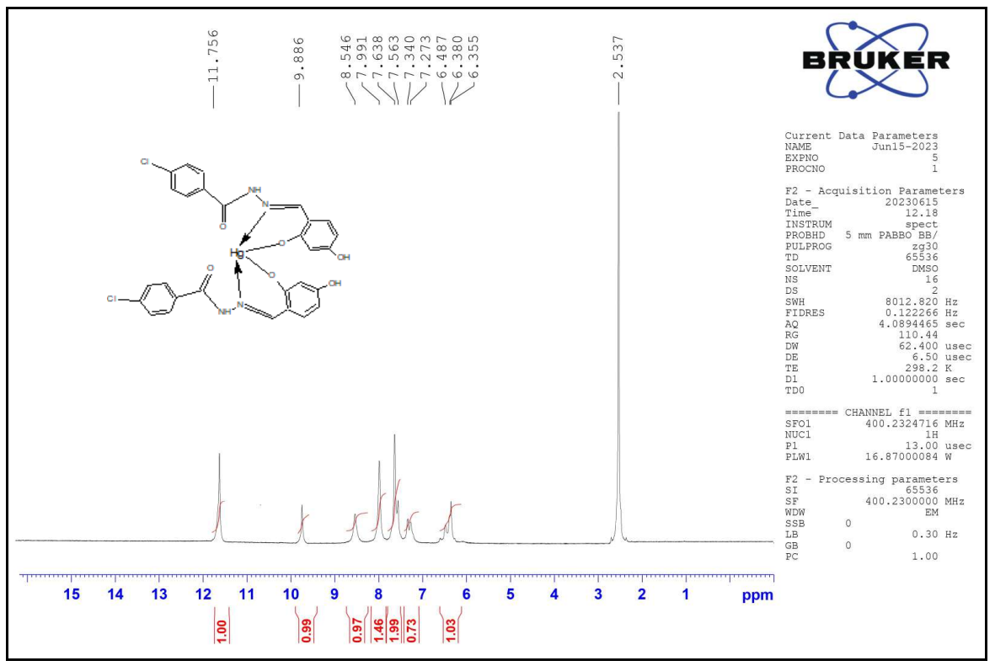
Figure 5:NMR spectrum of [Hg(BHDH)₂] complex
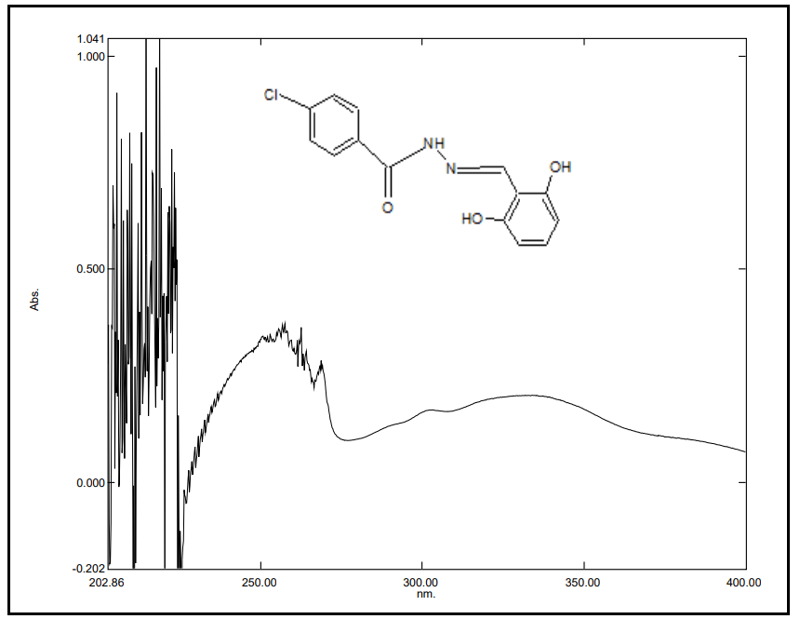
Figure 6:UV Spectrum of HBHDH ligand
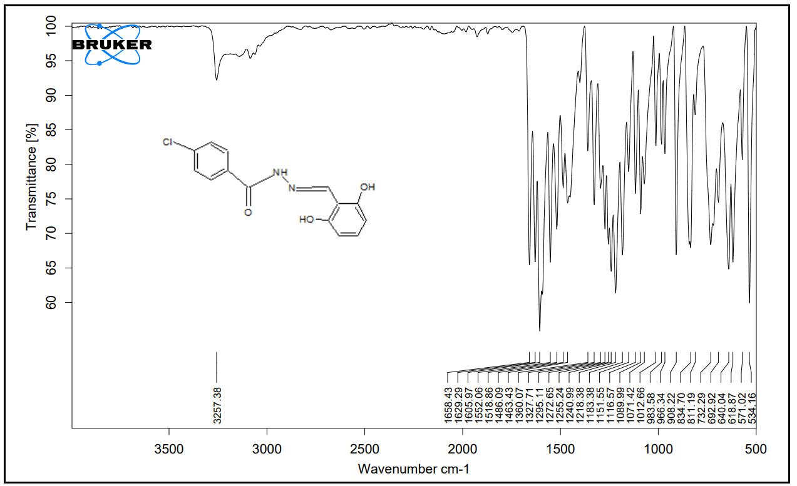
Figure 7:FT(IR) spectrum of HBHDH ligand
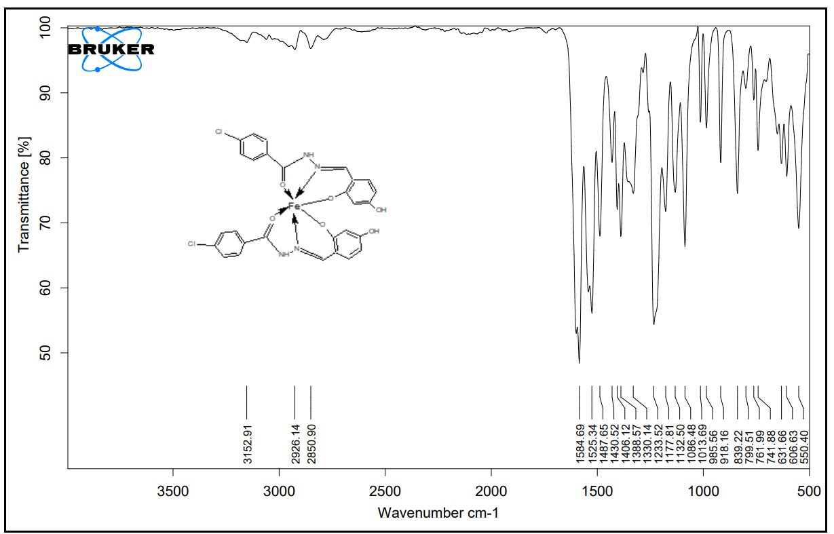
Figure 8:FT(IR) spectrum of [Fe(BHDH)₂] complex
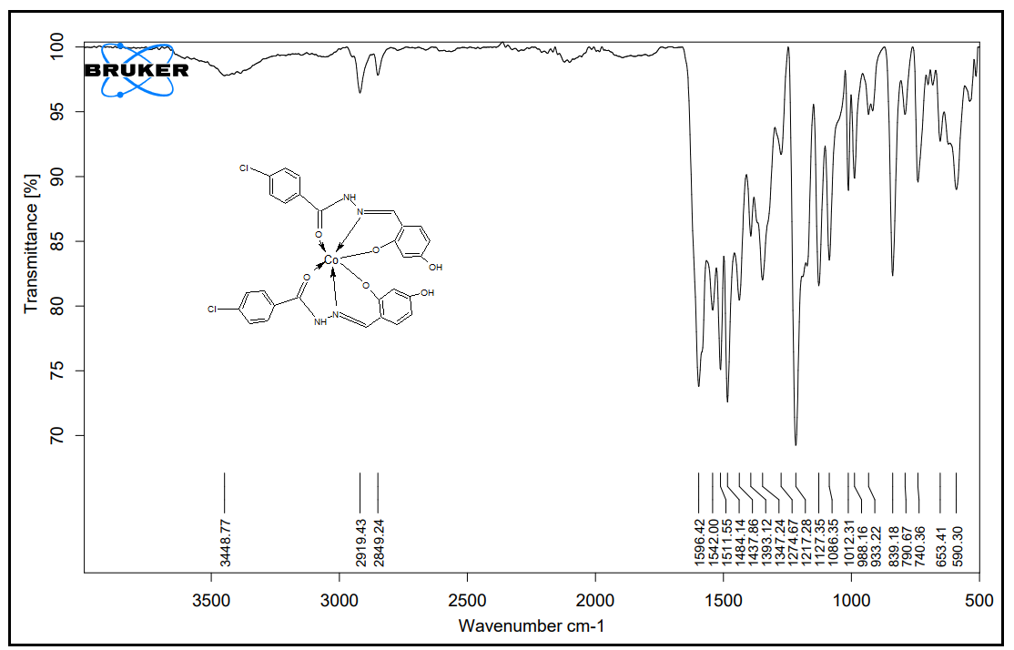
Figure 9:FT(IR) spectrum of [Co(BHDH)₂] complex
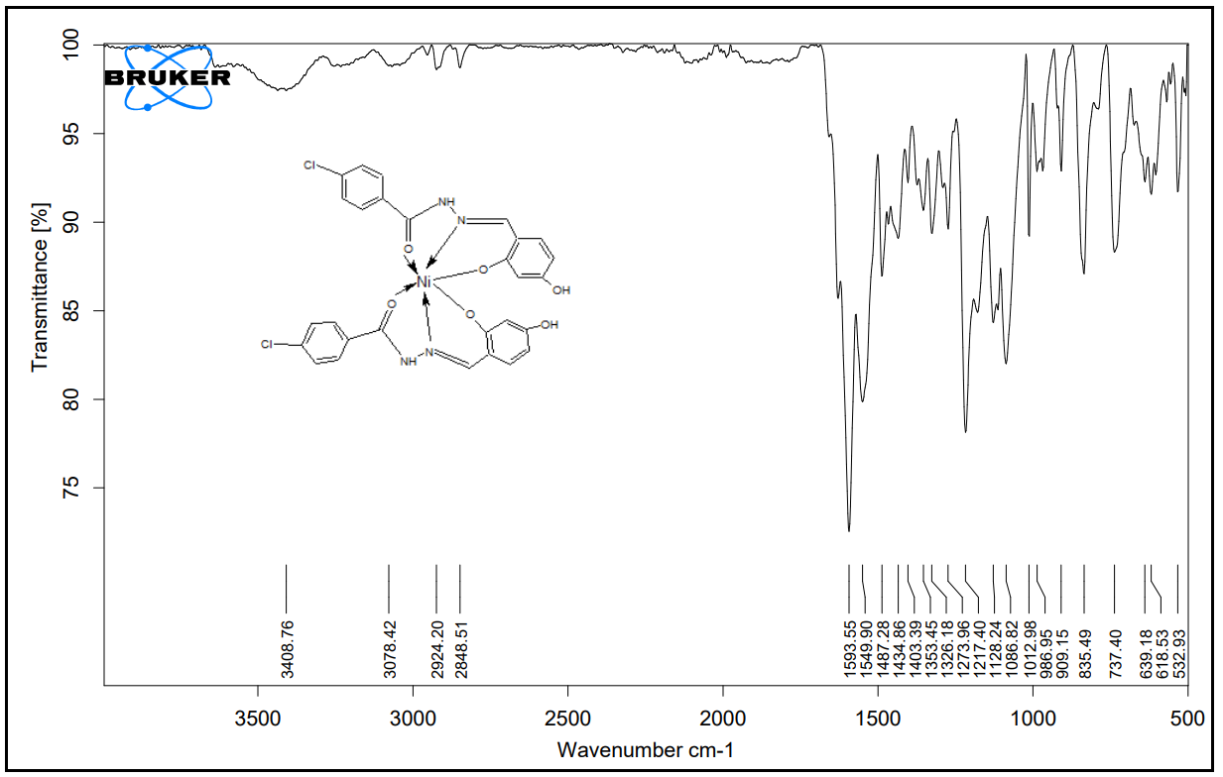
Figure 10:FT(IR) spectrum of [Ni(BHDH)₂] complex
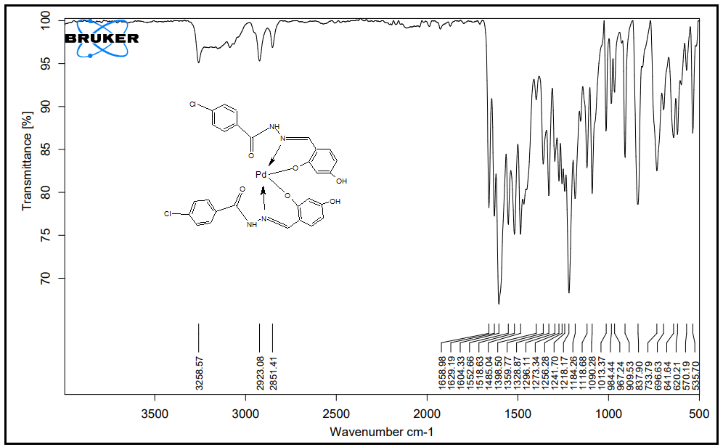
Figure 11:FT(IR) spectrum of [Pd(BHDH)₂] complex
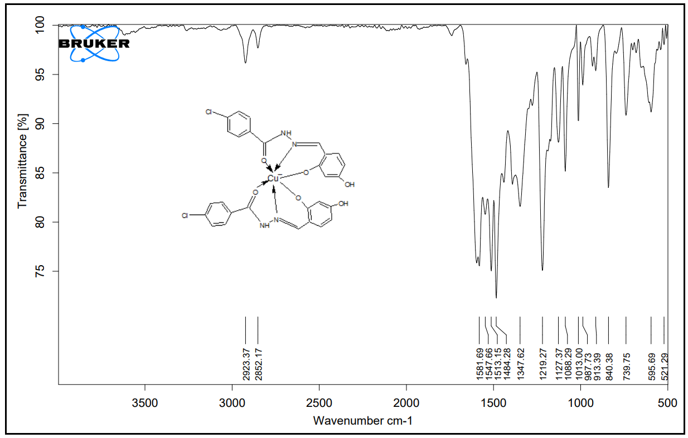
Figure 12:FT(IR) spectrum of [Cu(BHDH)₂] complex
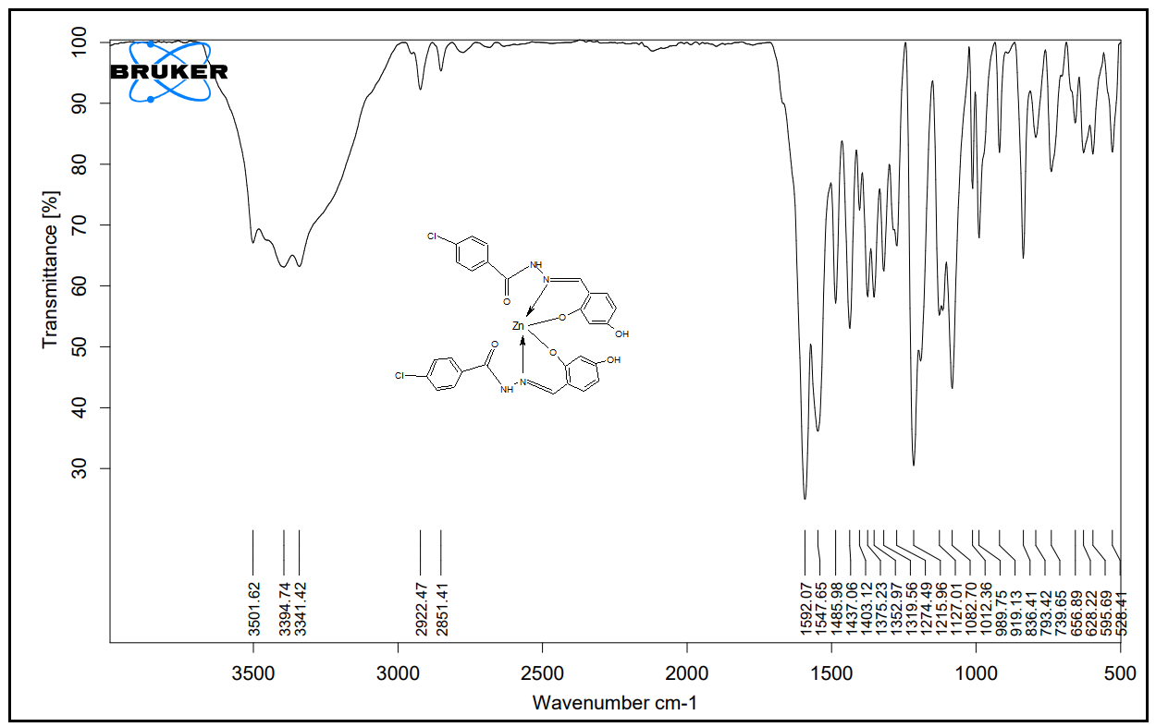
Figure 13:FT(IR) spectrum of [Zn(BHDH)₂] complex
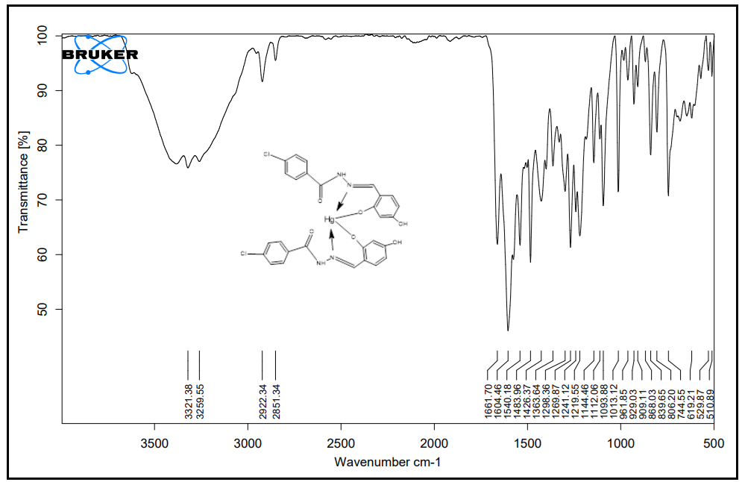
Figure 14:FT(IR) spectrum of [Hg(BHDH)₂] complex
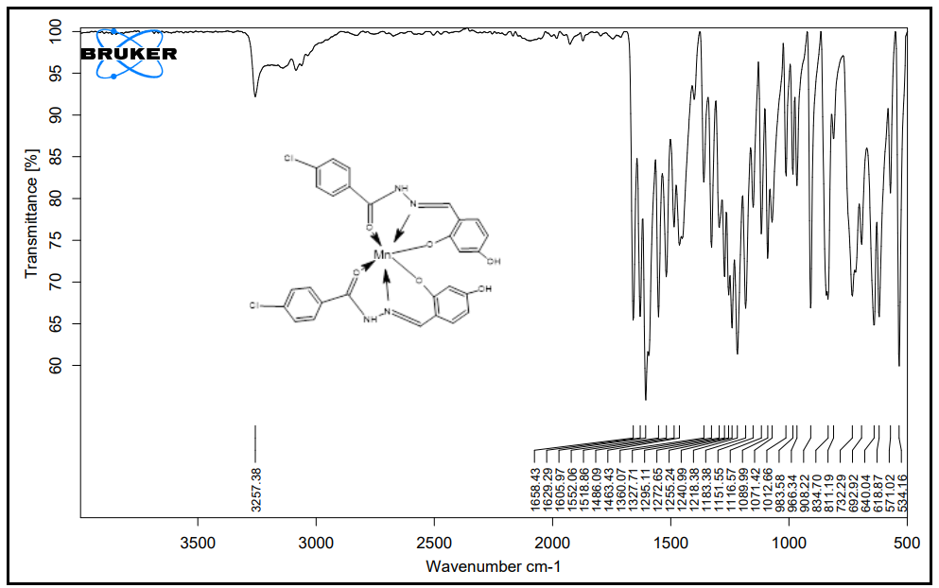
Figure 15:FT(IR) spectrum of [Mn(BHDH)₂] complex

