Isolation and characterization of bis(2-ethylheptyl) phthalate from Cynodon dactylon (L.) and studies on catalytic activity of its Cu(II) complex in the green preparation of 1,8-dioxo-octahydroxanthenes

Ali Allahresani *, Fatemeh Ghorbanyan, Mohammad Ali Nasseri, Milad Kazemnejadi
Department of Chemistry, Faculty of Science, University of Birjand, P. O. Box 97175-615, Birjand, Iran.
* Corresponding author: manaseri@birjand.ac.ir (M. A. Nasseri)

Fig. S1 FTIR spectrum of bis(2-ethylheptyl) phthalate

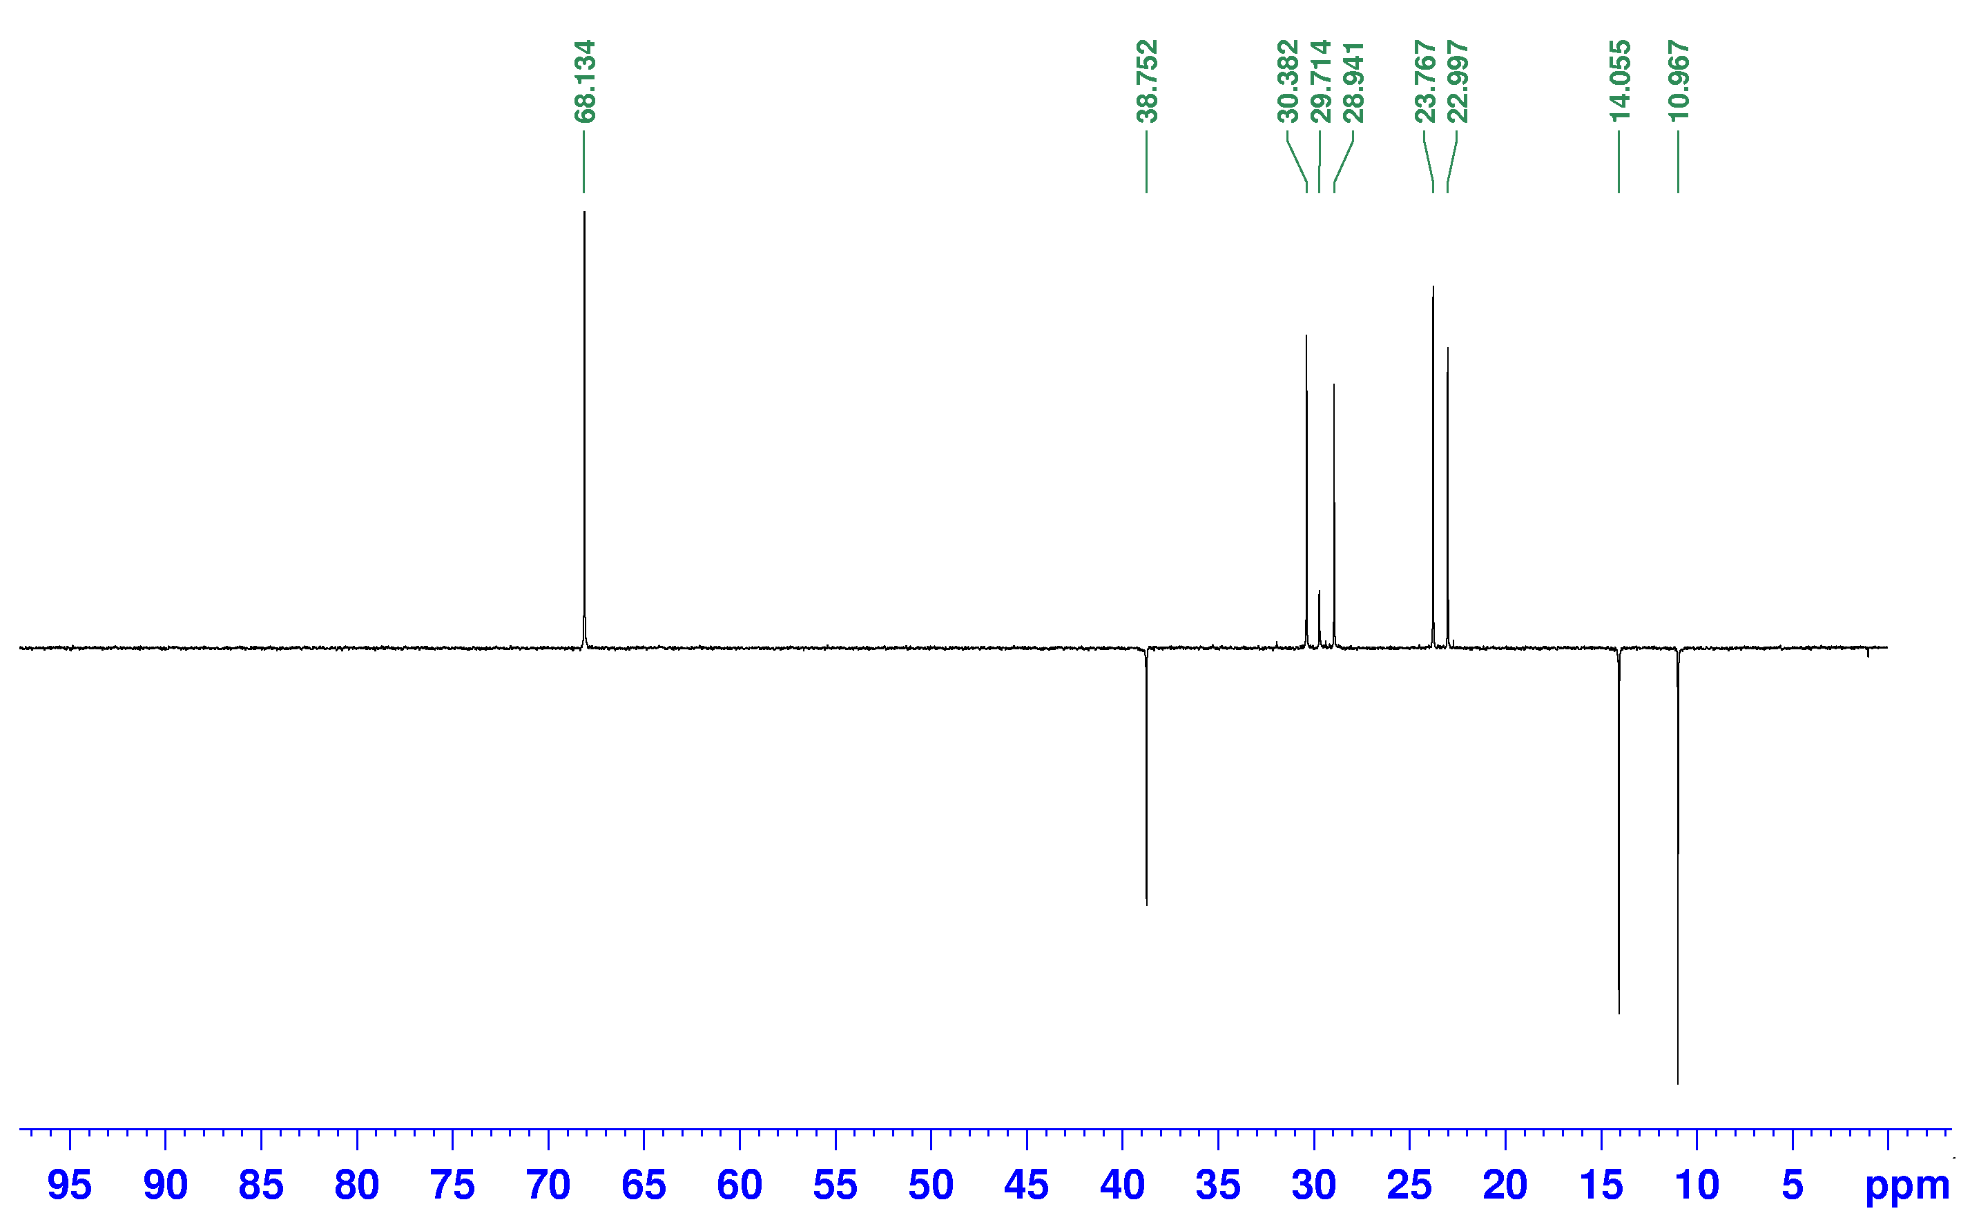
Fig. S2 DEPT spectrum of bis(2-ethylheptyl) phthalate (75 MHz, CDCl₃)
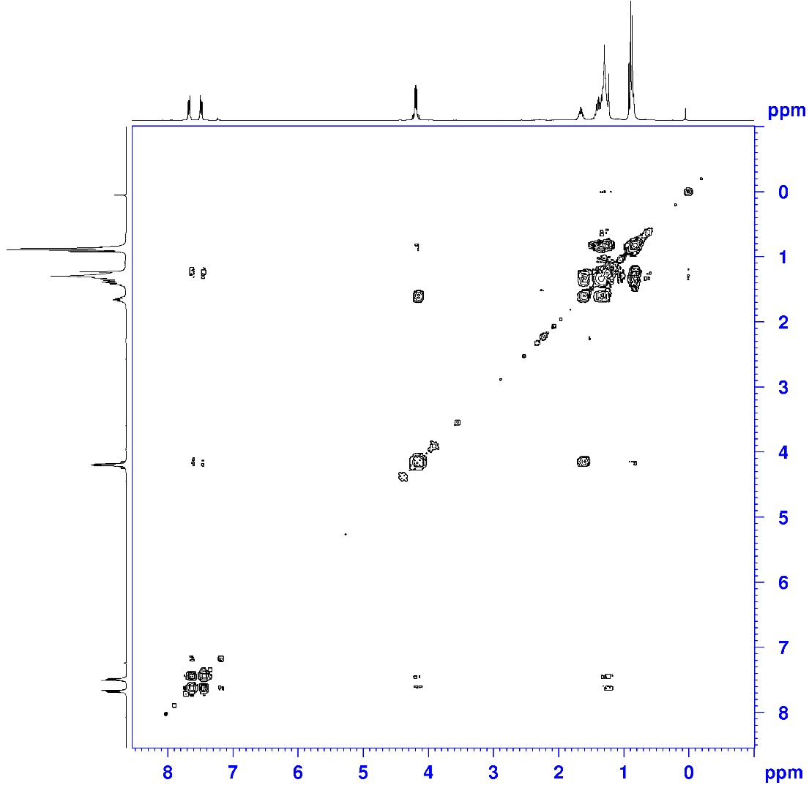
Fig. S3 H-H COSY spectrum of bis(2-ethylheptyl) phthalate (300 MHz, CDCl₃)
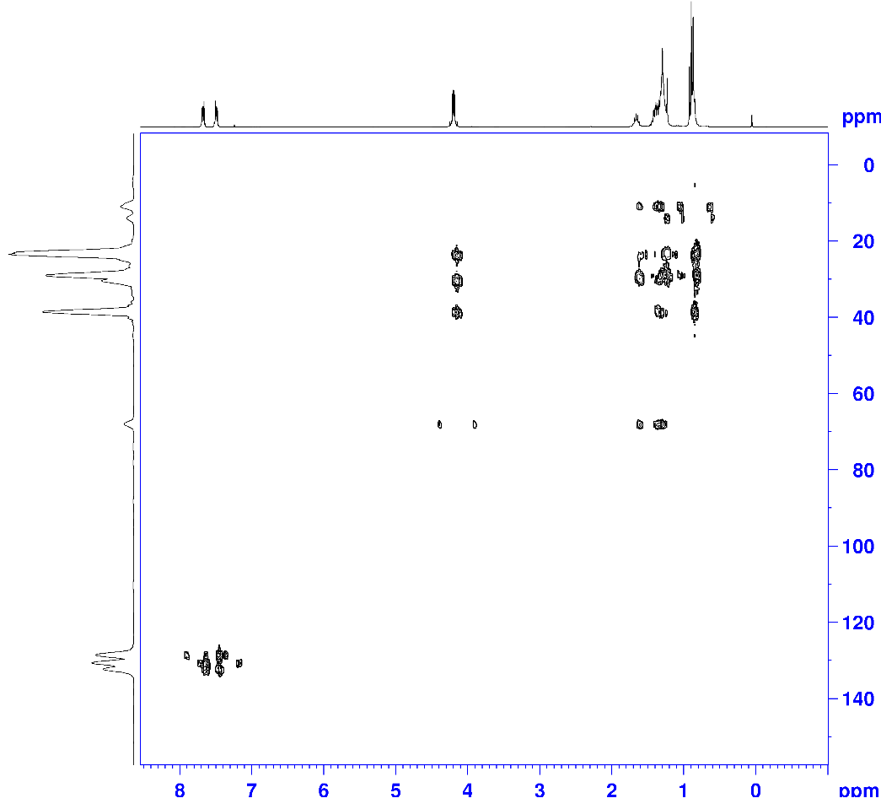
Fig. S4 HMBC spectrum of bis(2-ethylheptyl) phthalate (CDCl₃)
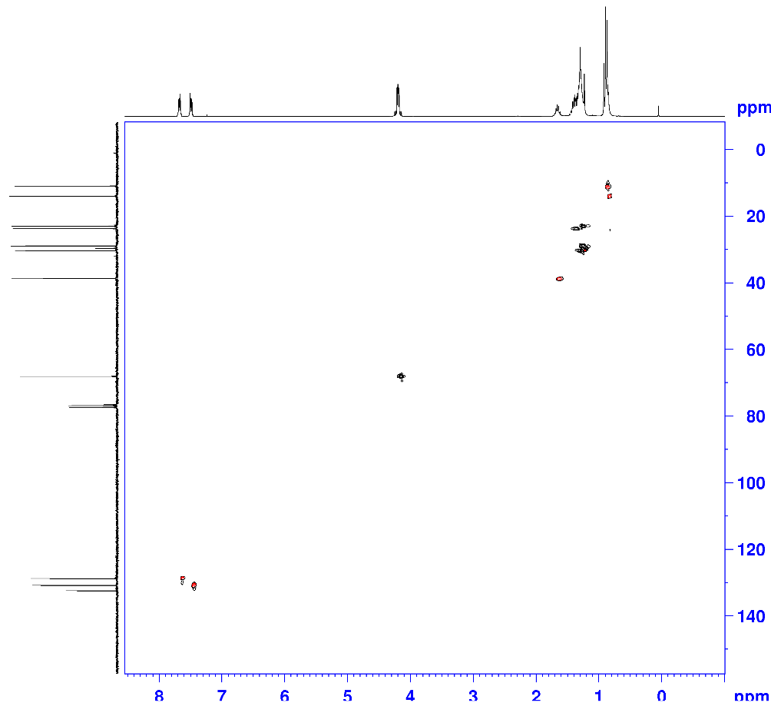
Fig. S5 HSQC spectrum of bis(2-ethylheptyl) phthalate (CDCl₃)
Characterization data for xanthene derivatives
9-(p-Tolyl)-3,4,5,6,7,9-hexahydro-1H-xanthene-1,8(2H)-dione (Table 3, 6a)
M.P. 244-246 °C; IR (KBr, cm⁻¹): 2977, 1662, 1533, 1364, 1329, 1220, 1158, 1132, 1081. ¹H NMR (300 MHz, DMSO-d₆, ppm): δ 1.95-2.08 (4H, m), 2.25 (3H, s), 2.30-2.44 (4H, m), 2.52-2.70 (4H, t, J= 6.2), 4.77 (1H, s), 7.03-7.08 (2H, d, J= 8 Hz), 7.12-7.25 (2H, d, J= 7.6 Hz) [1].

9-(4-chlorophenyl)-3,4,5,6,7,9-hexahydro-1H-xanthene-1,8(2H)-dione (Table 3, 6b)
IR (KBr, cm⁻¹): 2951, 1660, 1512, 1373, 1333, 1218, 1191, 1135, 1008, 832, 733. ¹H NMR (300 MHz, DMSO-d₆, ppm): δ 1.56 (4H, m), 1.94 (4H, m), 2.96 (4H, t, J= 6.3), 3.98 (1H, s), 7.19 (4H, m) [2].

9-(m-tolyl)-3,4,5,6,7,9-hexahydro-1H-xanthene-1,8(2H)-dione (Table 3, 6c)
IR (KBr, cm⁻¹): 3143, 2954, 1720, 1587, 1375, 1199. ¹H NMR (300 MHz, CDCl₃, ppm): 2.20 (4H, m), 2.24 (3H, s), 2.45 (4H, m), 2.54 (4H, t, J= 6.1), 4.70 (1H, s), 7.00 (2H, s, J= 8.1 Hz), 7.15 (2H, d, J= 8.1 Hz) [3].

9-(4-hydroxyphenyl)-3,4,5,6,7,9-hexahydro-1H-xanthene-1,8(2H)-dione (Table 3, 6d)
M.P. 250 °C, IR (KBr, cm⁻¹): 3498, 3078, 2933, 2929, 1719, 1645, 1577, 1384, 1166. ¹H NMR (300 MHz, CDCl₃, ppm): δ 2.12-2.24 (4H, m), 2.45 (4H, m), 3.15 (4H, t, J= 6.2), 4.61 (1H, s), 6.77 (2H, m) 6.93 (2H, m), 9.06 (1H, s) [4].

9-Phenyl-3,4,5,6,7,9-hexahydro-1H-xanthene-1,8(2H)-dione (Table 3, 6e)
M. P. 214-216 °C; IR (KBr, cm⁻¹): 3001, 1661, 1532, 1367, 1332, 1221, 1160, 1134, 1091, 841, 739. ¹H NMR (300 MHz, DMSO-d₆, ppm): δ 1.90-2.10 (4H, m), 2.27-2.28 (2H, t, J= 6.2), 2.31-2.40 (2H, t, J= 6.2 ), 2.52-2.65 (4H, m), 4.77 (1H, s), 7.05-7.09 (2H, t, J= 7.6 Hz), 7.12-7.13 (1H, d, J= 8.4 Hz), 7.23-7.31 (2H, dd, J= 8, 24.3) [1].

9-(2-hydroxyphenyl)-3,4,5,6,7,9-hexahydro-1H-xanthene-1,8(2H)-dione (Table 3, 6f)
Mp: 214°C; FT-IR (KBr, cm⁻¹): 3030, 2965, 1677, 1669, 1643. ¹H NMR (300 MHz, CDCl₃, ppm): δ 2.21 (4H, m), 2.45 (4H, m), 2.55 (4H, t, J= 6.3), 4.67 (1H, s), 6.61 (2H, d, J= 8.0 Hz), 7.11 (2H, d, J= 8.0 Hz), 9.68 (1H, s) [4].

9-(4-nitrophenyl)-3,4,5,6,7,9-hexahydro-1H-xanthene-1,8(2H)-dione (Table 3, 6g)
M.P. 222 °C; FT-IR (KBr, cm⁻¹): 3107, 3078, 2930, 2862, 1908, 1772, 1620, 1607, 1589, 1520, 1466, 1382, 1317, 1248. ¹H NMR (300 MHz, CDCl₃, ppm): δ 2.20 (2H, d, J= 16.3 Hz), 2.29 (2H, d, J= 16.3 Hz), 2.53 (4H, m), 2.57 (4H, t, J= 6.5 Hz), 4.86 (1H, s), 7.51 (2H, dd, J1= 7.0 Hz, J2= 1.7 Hz), 8.12 (2H, dd, J1= 7.0 Hz, J2= 1.7 Hz) [5].

9-(4-methoxyphenyl)-3,4,5,6,7,9-hexahydro-1H-xanthene-1,8(2H)-dione (Table 3, 6h)
M.P. >220 °C; FT-IR (KBr, cm⁻¹): 3068, 2943, 2887, 1639, 1608, 1458, 1364, 1232, 1176. ¹H NMR (300 MHz, CDCl₃, ppm): δ 1.96-2.07 (4H, m), 2.29-2.42 (4H, m), 2.52-2.69 (4H, t, J= 6.2 Hz), 3.26 (1H, s), 3.56 (3H, s), 7.03-7.05 (2H, d, J= 8.0 Hz), 7.12-7.21 (2H, d, J= 7.6 Hz) [6].

4-(1,8-Dioxo-2,3,4,5,6,7,8,9-octahydro-1H-xanthen-9-yl)benzonitrile (Table 3, 6i)
FT-IR (KBr, cm⁻¹): 3071, 3008, 2920, 2868, 1646, 1618, 1438, 1366, 1592, 1388, 1293, 1235, 1196, 1091. ¹H NMR (300 MHz, CDCl₃, ppm): δ 2.11 (4H, m), 2.49 (4H, m), 3.19 (4H, t, J= 6.4 Hz), 3.92 (1H, s), 7.71 (2H, d, J= 8.1 Hz), 7.50 (2H, d, J= 7.9 Hz).

9-(2-Furyl)-3,3,6,6-tetramethyl-3,4,6,7-tetrahydro-2H-xanthene-1,8(5H,9H)-dione (Table 3, 6j)
M.P. 180–181 °C; FT-IR (KBr, cm⁻¹): 3092, 2962, 1660, 1621, 1470, 1199. ¹H NMR (300 MHz, CDCl₃, ppm): δ 1.01 (6H, s), 1.13 (6H, s), 2.18 (4H, s), 2.52 (4H, s), 4.85 (1H, s), 7.43 (1H, t, J= 6Hz), 7.84 (1H, d, J= 4Hz), 8.01 (1H, d, J= 6Hz) [1].

3,3,6,6-tetramethyl-9-(pyridin-2-yl)-3,4,5,6,7,9-hexahydro-1H-xanthene-1,8(2H)-dione (Table 3, 6k)
M.P. 204-205 °C; IR (KBr, cm⁻¹): 2958, 2930, 2874, 1681, 1657, 1623, 1199. ¹H NMR (300 MHz, CDCl₃): δ 0.99 (6H, s), 1.10 (6H, s), 2.15 (2H, d, J= 16.2), 2.23 (2H, d, J= 16.2), 2.44 (2H, d, J= 17.4), 2.52 (2H, d, J= 17.4), 4.85 (1H, s), 6.94–7.02 (1H, m), 7.55– 8.38 (3H, m) [7].

9-(1H-Indol-3-yl)-3,3,6,6-tetramethyl-3,4,5,6,7,9-hexahydro-1H-xanthene-1,8(2H)-dione (Table 3, 6l)
M.P. 204-205 °C; IR (KBr, cm⁻¹): 3490, 3400, 3060, 2958, 2930, 2855, 2874, 1617, 1557, 1505, 1488, 1456, 1416, 1377, 1336, 1206, 1199, 1091, 1061. ¹H NMR (300 MHz, CDCl₃): δ 1.11 (6H, s), 1.19 (6H, s), 1.83 (4H, s), 2.01 (4H, s), 3.84 (1H, s), 6.94 (1H, t, J= 7.7 Hz), 7.06 (1H, t, J= 7.8 Hz), 7.17 (1H, s), 7.39 (1H, d, J= 8.0 Hz), 7.54 (1H, d, J= 8.2 Hz), 10.34 (1H, s).

3,3,6,6-tetramethyl-9-(thiophen-2-yl)-3,4,5,6,7,9-hexahydro-1H-xanthene-1,8(2H)-dione
(Table 3, 6m)
M.P. 163-164 °C; IR (KBr, cm⁻¹): 2957, 2895, 2872, 1659, 1622, 1371, 1360, 1200. ¹H NMR (300 MHz, CDCl₃): δ 1.06 (6H, s), 1.11 (6H, s), 2.26 (4H, s), 2.46 (4H, s), 5.15 (1H, s), 6.81–7.03 (3H, m) [8].

3,3,6,6-tetramethyl-9-(naphthalen-2-yl)-3,4,5,6,7,9-hexahydro-1H-xanthene-1,8(2H)-dione (Table 3, 6n)
M.P. >300°C; IR (KBr, cm⁻¹): 3059, 2954, 2922, 1649, 1608, 1491, 1364, 1221, 1171. ¹H NMR (300 MHz, CDCl₃): δ 0.99 (6H, s), 1.12 (6H, s), 2.13-2.18 (2H, d, J= 18 Hz), 2.21-2.23 (2H, d, J= 9.6 Hz), 2.52 (4H, s), 7.34- 7.38 (1H, d, J= 16), 7.46-7.47 (2H, d, J= 6.8 Hz), 7.73-7.79 (4H, m), 9.12 (1H, s) [9].

3,3,6,6-tetramethyl-9-(p-tolyl)-3,4,5,6,7,9-hexahydro-1H-xanthene-1,8(2H)-dione (Table 3, 6o)
M.P. 215-217 °C; IR (KBr, cm⁻¹): 3039, 2958, 1679, 1664, 1467, 1357, 1198, 1137. ¹H NMR (300 MHz, CDCl₃): δ 1.02 (6H, s), 1.12 (6H, s), 2.18 (2H, d, J= 16.2 Hz), 2.26 (2H, d, J= 16.2 Hz), 2.28 (3H, s), 2.48 (4H, s), 4.73 (1H, s), 7.04 (2H, d, J= 8.1 Hz), 7.20 (2H, d, J= 8.1 Hz) [10].

9-(4-chlorophenyl)-3,3,6,6-tetramethyl-3,4,5,6,7,9-hexahydro-1H-xanthene-1,8(2H)-dione (Table 3, 6p)
M.P. 230–232 °C; FT-IR (KBr, cm⁻¹): 3044, 2964, 1661, 1626, 1469, 1362, 1198. ¹H NMR (300 MHz, CDCl₃, ppm): δ 1.00 (6H, s), 1.11 (6H, s), 2.18 (2H, d, J= 16Hz), 2.25 (2H, d, J= 16Hz), 2.48 (4H, s), 4.72 (1H, s), 7.22 (2H, d, J= 4Hz), 7.27 (2H, d, J= 4Hz) [1].

9-(4-hydroxyphenyl)-3,3,6,6-tetramethyl-3,4,5,6,7,9-hexahydro-1H-xanthene-1,8(2H)-dione (Table 3, 6q)
M.P. 250-251 °C; IR (KBr, cm⁻¹): 3498, 3078, 2933,2929, 1719, 1645, 1577, 1384, 1166. ¹H NMR (300 MHz, CDCl₃): δ 1.00 (6H, s), 1.11 (6H, s), 2.12-2.24 (4H, s), 2.45 (4H, s), 4.61 (1H, s), 6.77 (2H, m), 6.93 (2H, m), 9.06 (1H, b) [11].

9-Phenyl-3,3,6,6-tetramethyl-3,4,6,7-tetrahydro-2H-xanthene-1,8(5H,9H)-dione (Table 3, 6r)
M.P. 200–202 °C; FT-IR (KBr, cm⁻¹): 3028, 2961, 1663, 1623,1454, 1359, 1197, 1000. ¹H NMR (300 MHz, CDCl₃, ppm): δ 1.00 (6H, s), 1.11 (6H, s), 2.17 (2H, d, J=16Hz), 2.25 (2H, d, J= 16Hz), 2.48 (4H, s), 4.76 (1H, s), 7.29 (5H, m) [1].

9-(2-Methoxyphenyl)-3,3,6,6-tetramethyl-3,4,6,7-tetrahydro-2H-xanthene-1,8(5H,9H)-dione (Table 3, 6s)
M.P. 178–179 °C; FT-IR (KBr, cm⁻¹): 3015, 2957, 1662, 1623, 1491, 1252, 1198; ¹H NMR (300 MHz, CDCl₃, ppm): δ 0.96 (6H, s), 1.01 (6H, s), 2.13 (2H, d, J= 18Hz), 2.21 (2H, d, J= 18Hz), 2.38 (2H, d, J=18Hz), 2.47 (2H, d, J= 18Hz), 3.78 (3H, s), 4.87 (1H, s), 6.76 (1H, d, J= 6Hz), 6.89 (1H, d, J= 4Hz), 7.42 (1H, d, J= 6Hz), 7.11 (1H, s) [1].

9-(4-Nitrophenyl)-3,3,6,6-tetramethyl-3,4,6,7-tetrahydro-2H-xanthene-1,8(5H,9H)-dione (Table 3, 6t)
M.P. 224–225 °C; FT-IR (KBr, cm⁻¹): 3057, 2959, 1663, 1616, 1515, 1470, 1343, 1201. ¹H NMR (300 MHz, CDCl₃, ppm): δ 1.00 (6H, s), 1.12 (6H, s), 2.17 (2H, d, J= 16Hz), 2.27 (2H, d, J= 16Hz), 2.51 (4H, s), 4.83 (1H, s), 7.48 (2H, d, J= 9Hz), 8.09 (2H, d, J= 9Hz) [1].

9-(4-Methoxyphenyl)-3,3,6,6-tetramethyl-3,4,6,7-tetrahydro-2H-xanthene-1,8(5H,9H)-dione (Table 3, 6u)
M.P. 240–242 °C; FT-IR (KBr, cm⁻¹): 3050, 2959,1666, 1625, 1435, 1261, 1195. ¹H NMR (300 MHz, CDCl₃, ppm): δ 1.00 (6H, s), 1.11 (6H, s), 2.21 (4H, d, J= 4Hz), 2.47 (4H, s), 3.74 (3H, s), 4.71 (1H, s), 6.76 (2H, d, J= 9Hz), 7.22 (2H, d, J= 9Hz) [1].

References
- Keshavarz, M, Abdoli-Senejani, M, Hojati, SF, & Moosavifar, M. (2017). Novel and highly efficient heteropoly acids for one-pot mild and green synthesis of xanthene derivatives. Organic Preparations and Procedures International, 49(6), 549-556.
- Khalafi-Nezhad, Ali, Panahi, Farhad, Mohammadi, Somayeh, & Foroughi, Habib Ollah. (2013). A green and efficient procedure for one-pot synthesis of xanthenes and acridines using silica boron–sulfuric acid nanoparticles (SBSANs) as a solid Lewis-protic acid. Journal of the Iranian Chemical Society, 10(2), 189-200.
- Khazaei, Ardeshir, Abbasi, Fatemeh, & Moosavi-Zare, Ahmad Reza. (2016). Catalytic application of N, 2-dibromo-6-chloro-3, 4-dihydro-2H-benzo [e][1, 2, 4] thiadiazine-7-sulfonamide 1, 1-dioxide as a new catalyst for the synthesis of 9-aryl-1, 8-dioxo-octahydroxanthenes under neutral media. Research on Chemical Intermediates, 42(8), 6719-6732.
- Böβ, Esther, Hillringhaus, Tim, Nitsch, Jacqueline, & Klussmann, Martin. (2011). Lewis acid-catalysed one pot synthesis of substituted xanthenes. Organic & Biomolecular Chemistry, 9(6), 1744-1748.
- Paliwal, Pradeep, Jetti, Srinivasa Rao, Bhatewara, Anjna, Kadre, Tanuja, & Jain, Shubha. (2013). DABCO catalyzed synthesis of Xanthene derivatives in aqueous media. ISRN Organic Chemistry, 2013.
- Sadeh, Fatemeh Noori, Fatahpour, Maryam, Hazeri, Nourallah, Maghsoodlou, Malek Taher, & Lashkari, Mojtaba. (2017). One-Pot Condensation Approach for the Synthesis of Some 1, 8-Dioxo-octahydroxanthenes and 14-Aryl-14H-dibenzo [a, j] Xanthenes Using Lactic Acid as an Efficient and Eco-Friendly Catalyst. Acta Chemica Iasi, 25(1), 24-37.
- Rahmani, S, & Amoozadeh, A. (2014). Nano Titanium Dioxide: Efficient and Reusable Heterogeneous Nano Catalyst for Synthesis of 1, 8-Dioxo-Decahydroacridines. 4, 91-98.
- Zhang, Zhan-Hui, & Tao, Xu-Ye. (2008). 2, 4, 6-Trichloro-1, 3, 5-triazine-promoted synthesis of 1, 8-dioxo-octahydroxanthenes under solvent-free conditions. Australian Journal of Chemistry, 61(2), 77-79.
- Purushothaman, Gayathri, & Thiruvenkatam, Vijay. (2018). Qualitative and quantitative analysis of intermolecular interactions in xanthenedione derivatives. Acta Crystallographica Section C: Structural Chemistry, 74(7), 830-838.
- Fathollahi, M., Rostamizadeh, S., & Amani, A. M. (2018). A Clean, Mild, and Efficient Preparation of Aryl 14H-benzo [a, j] xanthene leuco-dye Derivatives via Nanocatalytic MCM-41-SO₃H under Ultrasonic Irradiation in Aqueous Media. Combinatorial Chemistry & High Throughput Screening, 21(1), 5-13.
- Ghasemzadeh, Mohammad Ali, Safaei-Ghomi, Javad, & Zahedi, Safura. (2013). Fe₃O₄ nanoparticles: a highly efficient and easily reusable catalyst for the one-pot synthesis of xanthene derivatives under solvent-free conditions. J. Serb. Chem. Soc, 78(6), 769-779.

